SOUTH RIBBLE BOROUGH COUNCIL

LOCAL CODE OF CORPORATE GOVERNANCE

MARCH 2023
South Ribble Borough Council

Local Code of Corporate Governance

- Introduction

The "Local Code of Corporate Governance" (the Local Code) sets out and describes the Council's commitment to corporate governance and identifies the arrangements that have been developed and maintained to enable the transparent and fair delivery of the Council’s work. Each year the Council prepares an annual governance statement which tests the internal control environment against our Local Code. The Local Code is an important document which provides the framework for our compliance with good governance standards.

- Background

The framework "Delivering Good Governance in Local Government" was first published by the Chartered Institute of Public Finance and Accountancy and the Society of Local Authority Chief Executives and Senior Managers (CIPFA/SOLACE) late in 2007. This framework has been reviewed by CIPFA and Solace in 2015 and a revised framework, Delivering Good Governance published in spring 2016. It details 7 core principles which should form the basis for each council’s Local Code. These will be considered below.

- What is Corporate Governance?

Each local authority operates through a governance framework. It is a system that sets out how we manage our obligations and behaviours and how we make decisions. For the purpose of this Local Code, South Ribble Borough Council has accepted the following definition of Corporate Governance:-

"Governance is about how local government bodies ensure that they are doing the right things, in the right way, for the right people, in a timely, inclusive, open, honest and accountable manner.

It comprises the systems and processes, and cultures and values, by which local authorities are directed and controlled and through which they account to, engage with and, where appropriate, lead their communities".

South Ribble Borough Council recognises that effective local government relies upon establishing and maintaining the public's confidence in both the elected Members and officials, which then underpins the credibility and confidence in the services that we provide. Good governance should focus on outcomes for residents and service users.

South Ribble Borough Council seeks to encourage the values of good governance to both our existing and potential partners through the promotion of these behaviours and by providing a clear and demonstrable lead.

- South Ribble Borough Council's Corporate Strategy

The Council’s vision is:

“A healthy and happy community, flourishing together in a safer and fairer borough that is led by a council recognised for being innovative, financially sustainable and accountable.”

The Council’s corporate priorities are:

  - An exemplary council
  - Thriving communities
  - A fair local economy that works for everyone
  - Good homes, healthy places and green spaces.

All the activities and work the council undertakes and delivers should be capable of being traced into the corporate priorities and the delivery or our vision. This ensures that residents can be clear as to why we are undertaking our works and making these decisions.

The priorities set what outcomes the Council is looking to deliver and the corporate projects the set how these outcomes will be delivered.

Also important for corporate governance, the corporate plan provides measures against which delivery can be assessed.

- Framework for the Local Code
The following seven core principles are taken from the International Framework: Good Governance in Public Sector (CIPFA/IFAC 2014). Good governance means:

Behaving with integrity, demonstrating strong commitment to ethical values and respecting the rule of law

Ensuring openness and comprehensive stakeholder engagement

Defining outcomes in terms of sustainable economic, social and environmental benefits

Determining the interventions necessary to optimize the achievement of the intended outcomes

Developing the entity’s capacity, including the capability of its leadership and the individuals within it

Managing risks and performance through robust internal control and strong public financial management

Implementing good practices in transparency, reporting, and audit, to deliver effective accountability

The diagram below, illustrates how the principles relate to each other.
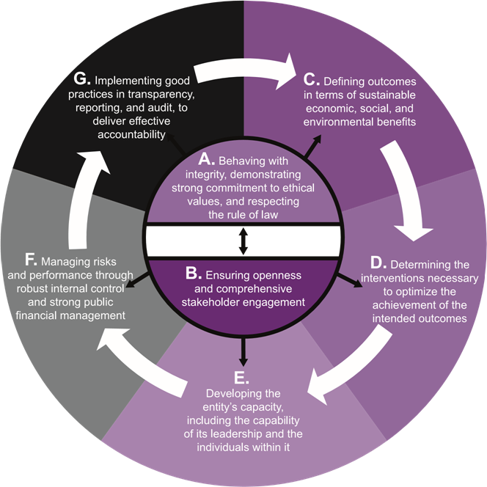

To demonstrate a strong governance environment, we have to demonstrate how we
comply with these principles.

The table below shows how the principles, statutory obligations and corporate priorities are supported by corporate documents and processes.

The tables at Appendix A set out the council’s specific approach and processes
which evidence compliance.

SOUTH RIBBLE BOROUGH COUNCIL CORPORATE GOVERNANCE FRAMEWORK
Principles, Statutory Obligations and Corporate Objectives
C

Local Vision Corporate Objectives Working Together Community Focus

Statutory Obligations Ethical Values Developing Individuals Effective Decisions

Corporate Governance comprises the systems and processes, cultures and values, by which local government are directed and controlled and through which they account to, engage with and where appropriate, lead their communities.

Key Documents:
Annual Review

Assurance Statements
Community Engagement Strategy
Constitution
Corporate Strategy
External Audit Plan & Report
Governance Review, Statement
& Action Plan
Internal Audit Plan
Medium Term Financial Strategy & Statement of Accounts
Organisational & Member
Development Plans
Pay Policy
Performance Framework
Performance Report
Risk Policies & Register
Service Plans
Treasury Strategy

Key Documents:
Ad-Hoc Review

Anti-Fraud Strategies & Plans
Business Continuity Policy
Codes of Conduct
Communications Guidelines
Complaints
Contract & Procurement Rules
Equalities Framework and Guidance
Financial Regulations
Freedom of Information and Data Protection Policies
Health, Safety and Welfare
Insurance Guidelines
Planning Procedures
Information Security & Technology
Strategies
Record of Decisions
RIPA Policy
Safeguarding
Strategic Risk Register Whistle Blowing Policy

Supporting Processes
Complaints Process
Council & Cabinet Meetings
Decision Making Process
Employee Survey
External Audits & Inspections
Governance Group & Annual Review
Governance, Scrutiny & Standards Committees
Corporate Governance Services
Head of Paid Service/Section 151/Monitoring Officer
Independent Remuneration Panel
Induction & Training Programmes
Performance & Financial Monitoring
Performance Management Framework
Job Descriptions
Regulatory Committees
Senior Leadership Team
Senior Management Team
Service Lead Internal Audit and Risk
Shared Assurance & Financial Services
Shared Services Joint Committee

